**ASSIGNMENT 2:**

**Module 3: Control Structures in Python**

**Task 1: Check if a Number is Even or Odd**

**Problem Statement:** Write a Python program that:

1. Takes an integer input from the user.

2. Checks whether the number is even or odd using an if-else statement.

3. Displays the result accordingly.

**Expected Output:**The program should return an output like:

|  |  |
| --- | --- |
|  |  |

**Task 2: Sum of Integers from 1 to 50 Using a Loop**

**Problem Statement:** Write a Python program that:

1. Uses a **for loop** to iterate over numbers from **1 to 50**.

2. Calculates the **sum** of all integers in this range.

3. Displays the final sum.

**Expected Output:**The program should return:

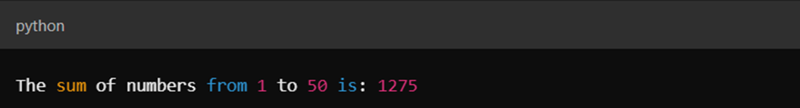

**Submission Instructions:**

* Create a **GitHub repository** and upload your Python scripts (.py files).
* Ensure the repository includes a **README.md** file that describes the functionality of your programs.
* Add both **Task 1 and Task 2** scripts in the same repository.
* Submit the **link to your GitHub repository** once uploaded.

**Reference:**

Follow the **Python course - Module 3: Control Structures in Python** for additional guidelines and examples.

**Note:**

**Please test your project thoroughly and check all the validations and error handling prior to ensure it works as expected before submission.**

**You can always connect to the mentor using the chat support option for any doubts or queries!**